2026 SOONER POAC Membership Form

Name:______________________________________ Date of Enrollment:__________________

Address:________________________________________________________________________

City:_________________________________State:___________Zip:_______________________

Phone:____________________________Email:________________________________________

NAME & BIRTHDAY OF ALL EXHIBITORS
THE NAME AND BIRTHDATE IS REQUIRED FOR ALL YOUTH AND ADULT EXHIBITORS FOR NATIONAL POAC & SOONER POAC POINTS. PLEASE COMPLETE THE BIRTHDAY AS FOLLOWS: MM/DD/YYYY.

____________________________________________________________________________________________

____________________________________________________________________________________________

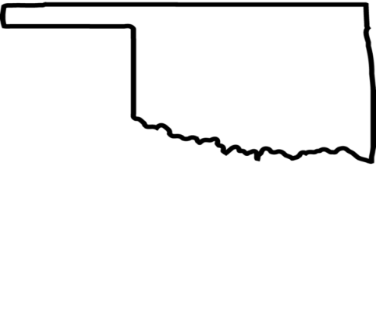
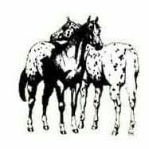
TYPE OF MEMBERSHIP:

____FAMILY MEMBERSHIP: $25.00
COMPLETE THIS FORM; INCLUDE YOUR FEES AND MAIL TO:
Brenda Faulkner, Sooner POAC Treasurer,
1405 Brixton Ct
Edmond, OK 73034

All communication to our Sooner POAC membership will be via either email, posted on the Sooner POAC Facebook page or posted on the website. Be sure to include your email address on this form to assure that you receive club information.

Payment for membership must be by check and not combined with any other payments

SOONER POAC WAIVER:
I agree that such entries are made at my own risk and subject to the rules on the Sooner Pony of the Americas Club, and I agree, for myself and my representatives to be bound thereby. I further agree to assume and accept full risk of injury or damage to property or myself, my family, or property as against the grounds owner, the Sooner POAC, or any of the officers, directors, or members of said associations. I further agree that the Sooner POAC show manager has the right to interpret all questions or conduct in regard to dispute regarding interpretations of the proper color or height to show.

Required Signature of Owner/Authorized Agent/Parental Consent Date

BOTH THE EXHIBITOR AND THE OWNER MUST BE A CURRENT MEMBER OF THE Sooner POAC IN ORDER TO BE ELIGIBLE FOR SOONER POAC YEAR-END AWARDS.

